Section I: Scenario Demographics

Scenario Title: | Aortic Dissection
Date of Development: | (10/01/2016)
Target Learning Group: | Juniors (PGY 1 – 2) Seniors (PGY ≥ 3) All Groups

Section II: Scenario Developers

Scenario Developer(s): | Martin Kuuskne
Affiliations/Institution(s): | University of Toronto
Contact E-mail (optional): | martin.kuuskne@gmail.com

Section III: Curriculum Integration

Learning Goals & Objectives
Educational Goal: | To recognize and manage a critically ill patient with aortic dissection and its potential cardiac complications.
CRM Objectives: | 1) Mobilize appropriate human resources in the work-up and disposition of aortic dissection.  2) Maintain and actively verbalize a wide differential diagnosis for the critically ill patient with chest pain.  3) Set priorities dynamically as the patient’s status changes.
Medical Objectives: | 1) Appropriately manage hypertension in the setting of aortic dissection with blood pressure and heart rate targets.  2) Recognize EKG manifestations of RCA involvement and resultant ischemia in the setting of aortic dissection.  3) Appropriately apply the ACLS algorithm for unstable bradycardia and asystole.

Case Summary: Brief Summary of Case Progression and Major Events
A 66 year old female with a history of smoking, HTN and T2DM presents with syncope while walking her dog. She complains of retrosternal chest pain radiating to her jaw. She will become increasingly bradycardic and hypotensive, requiring the team to mobilize resources in order to facilitate diagnosis and management of an aortic dissection.

References
Marx, J. A., Hockberger, R. S., Walls, R. M., & Adams, J. (2013). Rosen's emergency medicine: Concepts and clinical practice. St. Louis: Mosby.
http://lifeinthefastlane.com/ccc/acute-aortic-dissection/

Section IV: Scenario Script

A. Clinical Vignette: To Read Aloud at Beginning of Case
You are working the day shift at a tertiary-care hospital. A 66-year old female is being wheeled into the resuscitation bay with a history of as syncopal episode. No family members or friends are present with the patient.
B. Scenario Cast & Realism
Patient: | Computerized Mannequin |  |  |  |  | Realism:  Select most important dimension(s) |  |  | Conceptual
 | Mannequin |  |  |  |  |  |  |  | Physical
 | Standardized Patient |  |  |  |  |  |  |  | Emotional/Experiential
 | Hybrid |  |  |  |  |  |  |  | Other:
 | Task Trainer |  |  |  |  |  |  |  | N/A
Confederates | Brief Description of Role
RN | To assist if asked, provide relevant history and current status of patient. Patient was walking her dog and had a syncopal episode witnessed by bystanders who called EMS.
C. Required Monitors
EKG Leads/Wires |  |  | Temperature Probe |  |  |  | Central Venous Line
NIBP Cuff |  |  | Defibrillator Pads |  |  |  | Capnography
Pulse Oximeter |  |  | Arterial Line |  |  |  | Other:
D. Required Equipment
Gloves |  |  | Nasal Prongs |  |  |  | Scalpel
Stethoscope |  |  | Venturi Mask |  |  |  | Tube Thoracostomy Kit
Defibrillator |  |  | Non-Rebreather Mask |  |  |  | Cricothyroidotomy Kit
IV Bags/Lines |  |  | Bag Valve Mask |  |  |  | Thoracotomy Kit
IV Push Medications |  |  | Laryngoscope |  |  |  | Central Line Kit
PO Tabs |  |  | Video Assisted Laryngoscope |  |  |  | Arterial Line Kit
Blood Products |  |  | ET Tubes |  |  |  | Other:
Intraosseous Set-up |  |  | LMA |  |  |  | Other:
E. Moulage
Mannequin dressed in female outdoor clothing

F. Approximate Timing
Set-Up: |  | 10 min |  | Scenario: | 10 min |  |  | Debriefing: |  | 15 min

Section V: Patient Data and Baseline State

A. Patient Profile and History
Patient Name: Dorothy Williams |  |  |  |  |  | Age: 66 |  |  |  |  |  |  |  | Weight: 50 kg
Gender: M F |  |  |  |  |  | Code Status: Full
Chief Complaint: Syncope
History of Presenting Illness: Walking the dog outside and suddenly fainted, seen by passerby who called ambulance.
Past Medical History: |  |  | HTN |  |  |  | Medications: |  |  |  |  | Amlodipine
 |  |  | T2DM |  |  |  |  |  |  |  |  | Metformin
 |  |  | No prev MI/CVA/PE |  |  |  |  |  |  |  |  | ASA
Allergies: NKDA
Social History: 30 pack year smoker
Family History: None contributory
Review of Systems: |  |  | CNS: |  | None
 |  |  | HEENT: |  | None
 |  |  | CVS: |  | Retrosternal chest pain radiating to right jaw, constant, sharp, x30 mins
 |  |  | RESP: |  | None (no SOB, no hemoptysis)
 |  |  | GI: |  | None
 |  |  | GU: |  | None
 |  |  | MSK: |  | None |  |  |  |  |  |  |  | INT: |  | None
B. Baseline Simulator State and Physical Exam
No Monitor Display |  |  |  | Monitor On, no data displayed |  |  |  |  |  |  | Monitor on Standard Display
HR: 110/min |  | BP: 210/100  (160/80 left arm only if asked) |  |  |  |  |  |  | RR: 20/min |  |  |  |  |  |  | O₂Sat: 99%
Rhythm: Sinus tach |  | T: 36.5ºC |  |  |  |  |  |  | Glucose: 5.0 mmol/L |  |  |  |  |  |  | GCS: 15 (E4 V5 M6)
General Status: No acute distress, no respiratory distress
CNS: | Normal
HEENT: | Normal
CVS: | Diastolic III/VI murmur
RESP: | Bi-basilar crackles
ABDO: | Normal
GU: | Normal
MSK: | Normal |  |  |  |  |  |  | INT: |  | Normal

Scenario States, Modifiers and Triggers
Patient State | Patient Status | Learner Actions, Modifiers & Triggers to Move to Next State
1. Baseline State  Rhythm: Sinus tach  HR: 110/min  BP: 210/100 (R)  160/80 (L) only if asked  RR: 20/min  O₂Sat: 99%  T: 36.5ºC | Alert.  Complaining of chest pain | Learner Actions  - Full set of vitals, monitors  - ECG  - CXR  - Start 2 Large Bore IV lines  - IV Labetolol OR  - IV Esmolol + Nitroprusside  - Orders Emergent CT chest | Modifiers  Changes to patient condition based on learner action  - Give negative inotrope  (HR→85, BP→150/96)  - Give vasodilator  (HR→85, BP→135/80)  - Give NTG SL  (BP→200/100 then increases)  Triggers  For progression to next state  - Give heparin → 4. Bradycardia-Asystolic arrest  - 4 minutes → 2. Increasing Chest Pain
2. Increasing Chest Pain  HR→50  BP→90/60 and decreasing | Complaining of severe chest pain | Learner Actions  - Repeat EKG (Mobitz I, inferior STE)  - Discontinue any prior β-blockers or vasodilators.  - Give IV fluids  - Atropine IV  - Call for CT chest (if not yet)  - Bedside U/S for PCE | Modifiers  - Give IV fluids BP 100/65  - Give atropine no change  Triggers  - 3 minutes → 3. Unstable Bradycardia
3. Unstable Bradycardia  HR→40/min  BP→70/30  RR→12/min | Acute distress | Learner Actions  - Initiate intubation  - Atropine IV  - Initiate transcutaneous pacing  - Consider IV inotropic/chronotropic agents  - Call ICU  - Bedside ultrasound for PCE  - Call for TEE  - Consult Cardiac surgery | Modifiers  - Give atropine no change  - Give IV chronotropic agents  BP 90/50  - Transcutaneous pacing  BP 90/50  Triggers  - END SCENARIO PRN with TEE or consultant arrival
4. Bradycardia-Asystolic arrest  Rhythm→asystole  HR→0/min  BP→0/0  RR→0/min  O₂Sat→0% | Non-responsive | Learner Actions  - High Quality CPR  - Epinephrine 1amp q3-5min  - ACLS  - Crash Intubation  - Monitor capnography | Modifiers  Triggers  - 1st round of CPR and epi given 3. Unstable Bradycardia  -Total scenario >10 minutes END SCENARIO
Section VI: Scenario Progression

Section VII: Supporting Documents, Laboratory Results, & Multimedia

Laboratory Results
Na: 137 | K: 4.9 |  |  | Cl: 101 |  | HCO₃: 24 |  | BUN: |  | Cr: |  |  | Glu: 5.0
Ca: |  |  | Mg: |  |  |  | PO₄: |  |  |  | Albumin:
VBG |  | pH: 7.23 |  |  | PCO₂: 30 |  | PO₂: |  | HCO₃: 25 |  |  | Lactate:2.9
WBC: 9.0 |  |  | Hg: 140 |  |  |  | Hct: |  |  |  | Plt: 360
Troponin: 358

Images (ECGs, CXRs, etc.)
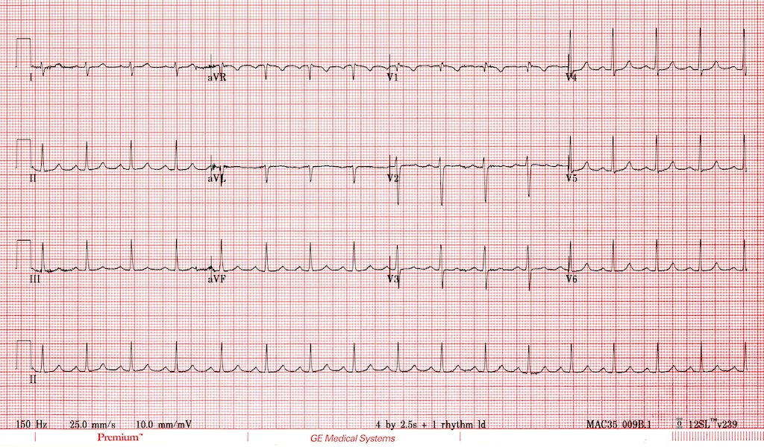  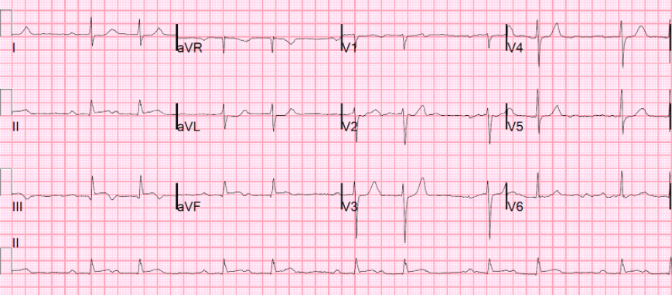 | 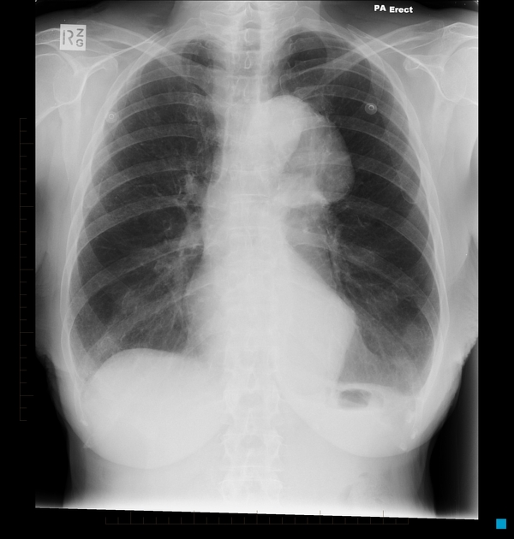  Retrieved from: https://radiopaedia.org/articles/aortic-dissection
Ultrasound Video Files (if applicable)

Section VIII: Debriefing Guide

General Debriefing Plan
Individual | Group |  | With Video | Without Video
Objectives
Educational Goal: |  | To recognize and manage a critically ill patient with aortic dissection and its potential cardiac complications.
CRM Objectives: |  | 1) Mobilize appropriate human resources in the work-up and disposition of aortic dissection.  2) Maintain and actively verbalize a wide differential diagnosis for the critically ill patient with chest pain.  3) Set priorities dynamically as patient status changes.
Medical Objectives: |  | 1) Appropriately manage hypertension in the setting of aortic dissection appropriate blood pressure and heart rate targets.  2) Recognize EKG manifestations of RCA involvement and resultant ischemia in the setting of aortic dissection.  3) Appropriately apply the ACLS algorithm for unstable bradycardia and asystole.
Sample Questions for Debriefing
1. At what point did you suspect this was a dissection? How common is syncope a presentation of dissection? (9%) AMI?(7%) Pulmonary Embolism? (10%)
2. What other items were on your differential?
3. What is the most time efficient way to rule out items on the differential for chest pain?
4. What is the best test that can be performed most EDs to rule in a dissection in the unstable patient?
5. How did your management priorities change for this patient with the change in vital signs?
6. Did the team feel like a cohesive unit today? Were there any challenges to your leadership or communication?
Key Moments
Recognition of aortic dissection
Change in management when patient became hypotensive
Initiation of transcutaneous pacing when patient became bradycardic

